Incident Reporting & Investigation System (IRIS)
IRIS Support Team User Guide

Author | Chris Sanders
Version Number | v0.2

Version | Update Date | Updated By | Comments
0.1 | 01/07/2020 | Chris Sanders | Guide created
0.2 | 20/09/2023 | Chris Sanders | Updated following look and feel, supplier change and process updates

Purpose

This guide will set out the main areas of support requests to be dealt with by administrators on the Incident Reporting & Investigation System (IRIS).

Those areas are:
- Adding/amending/removing user accounts and permissions on IRIS
  - Add a new user account to IRIS
  - Amend a user’s account and their permissions
  - Remove a user account
- Adding/amending/removing department details on IRIS
  - Add a new department to IRIS
  - Amend a department’s details
  - Remove a department
- Adding/amending/removing building details on IRIS
  - Add a new building to IRIS
  - Amend a building’s details
  - Remove a building
- Reassigning incidents from one department to another
- Amending details entered on Incident Forms
- Functionality changes
  - Amend options in a dropdown list

Requirements

Fulfilment of the admin role on IRIS requires the following:
- An account on IRIS with the user group Administrator with unrestricted access on the system
- To have been trained by another member of the IRIS Admin Team or the Business Service Manager
- To have completed the Service Desk Analyst training on Oxford Service Manager (OSM)
- To have been added to the Safety Office IRIS Support Team group on OSM

Not included in this guide

- Guidance on the use of tickets and tasks in OSM

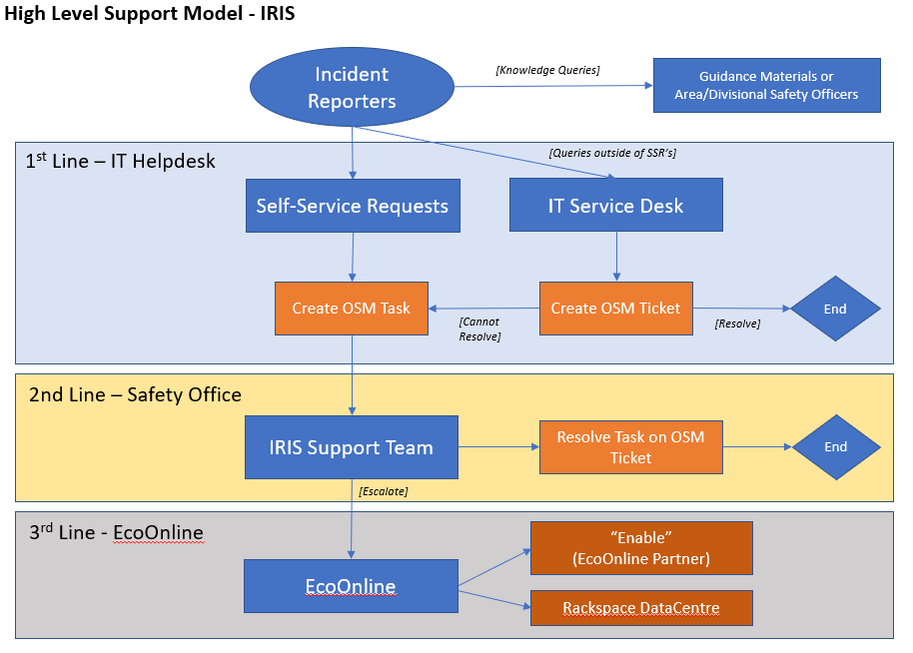

Queries will come to you in one of two ways:
- As tasks on OSM to be investigated and actioned
- Via email, either personal or Safety Office mailbox. This is not the primary way of support queries coming to the team to process and this behaviour should be discouraged for future use when it occurs. Once received via email, a ticket will need to be created on OSM and processed from there.

Investigation of Requests

Queries that come into the IRIS Support Team via tasks on OSM, may include requests that need to be verified with safety contacts throughout the University e.g. a request to create a new department in NDM would need to be checked with one of the Area Safety Officers for Medical Science if the request did not come from them.

Times when this is appropriate will be highlighted in the guidance that follows.

Escalations

There are two avenues of escalation for requests that come in via OSM:
- Escalation to the IRIS Product Ownership Group (POG) for discussion and decision
- Escalation to the supplier EcoOnline

In both instances, tasks that require escalation should be done so initially to the Business Change Analyst.

Alcumus Helpdesk: infoexchange.helpdesk@ecoonline.com
01926 844211

- Adding/Amending/Removing User Accounts and Permissions

Access the IRIS system using your SSO ID and password: IRIS Single Sign-On Login

NB. The system requires the use of a VPN to access the system from home or outside of the University network.

Access the Administration module using the icon on the Homepage.

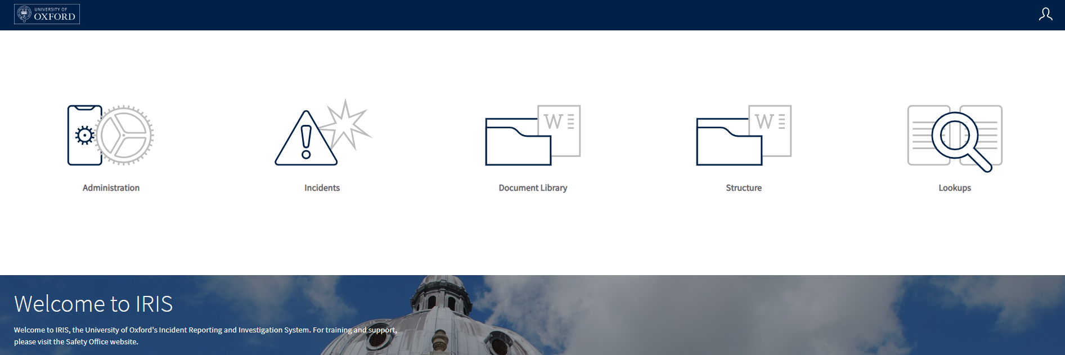

You are then faced with a list of users on the system.

  - Adding a user account and assigning permissions

First check that the account requested does not already exist on the system by using the search. If needs be, you can select All Users from the dropdown list to show not only current, active accounts but also archived ones.

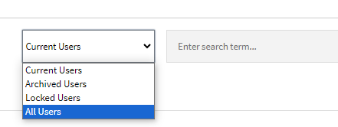

If no account exists for the requested person, the following message will be displayed.

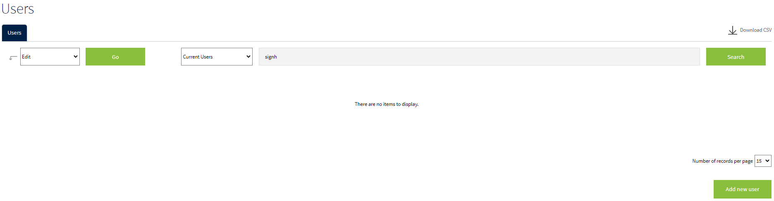

Click on Add New User to create a new account.

Complete the Forename, Surname and Email Address for the new account.

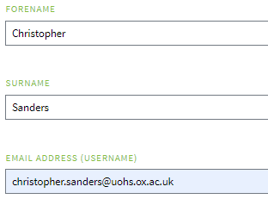

Click on the […] button by Company and select University of Oxford. Click Ok.

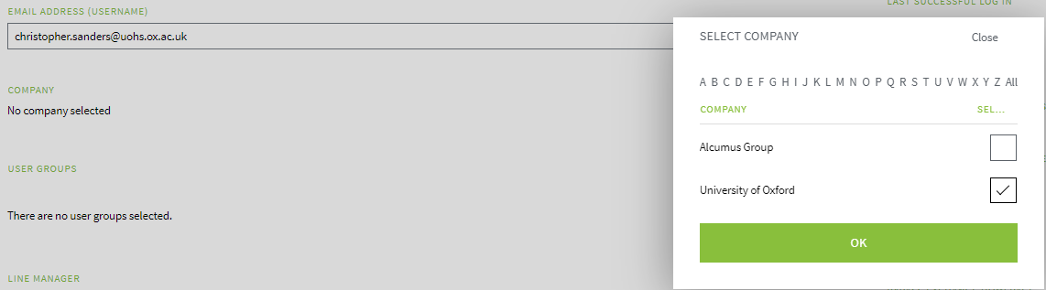

Click on the […] button by User Groups. Select the appropriate User Group for the new account. Click Ok.

NB. The same account can be part of multiple user groups. This is common for Departmental Safety Officers who are also Departmental Fire Officers and/or Biological Safety Officers.

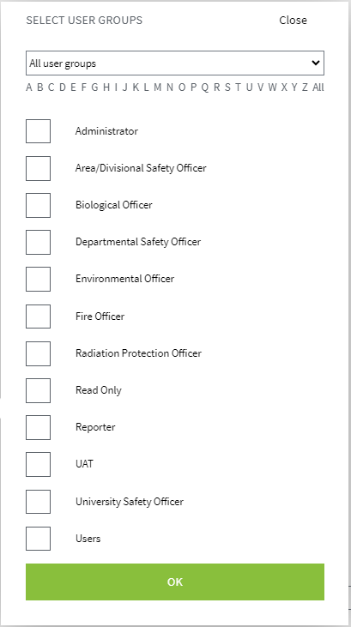

Ensure that the Enable Manual Login option is NOT ticked. Being ticked will force the user to try to manually log in instead of using SSO.

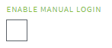

On the right-hand side of the page, enter the user’s SSO ID in the Authentication ID field. This must be in the format abcd1234@ox.ac.uk.

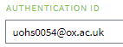
Click Save at the bottom of the page. This will return you to the user list.

You now need to apply the permissions for the division(s) or department(s) the user will have responsibility for.

Click on Menu icon in the blue banner (4 squares icon) at the top right-hand side of the page. Click on the Structure module icon.

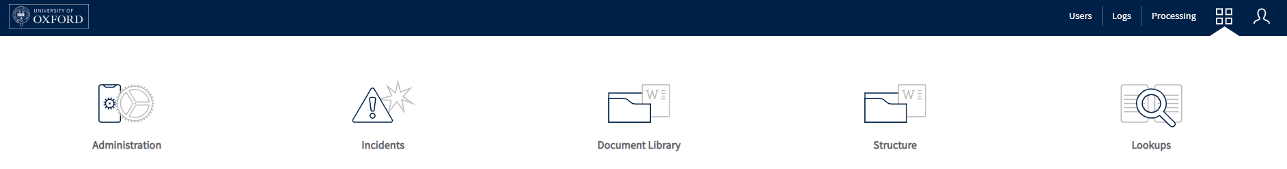

IRIS has a three-tiered structure of Divisions, Departments and Sub-Departments built into it. Permissions can be applied at any of these three levels and trickle down e.g. Read permissions applied at a Leve 1 Entity (a Division) will trickle down so that the user can have the same Read permissions for all Departments and Sub-Departments in that Division.
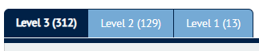

Navigate to the entity where the permission needs to be applied using the tabs and the search field if required. The search field will only search within the tab you are currently in. Best practice here would be start at the Level 1 Entity and navigate down until you find where the permission needs to be applied.

In the following example we will apply “Edit” permissions to a user for the Human Genetics WT Centre.

In the Level 1 Entity tab, select the correct Division (in this example Medical Sciences)

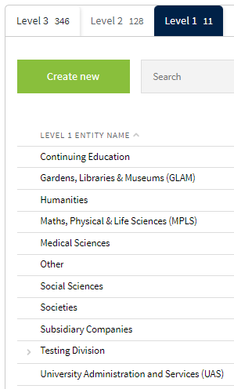

This opens up a list of Level 2 Entities associated with that Level 1 Entity. Select the correct Level 2 Entity (in this example Nuffield Department of Medicine (NDM))

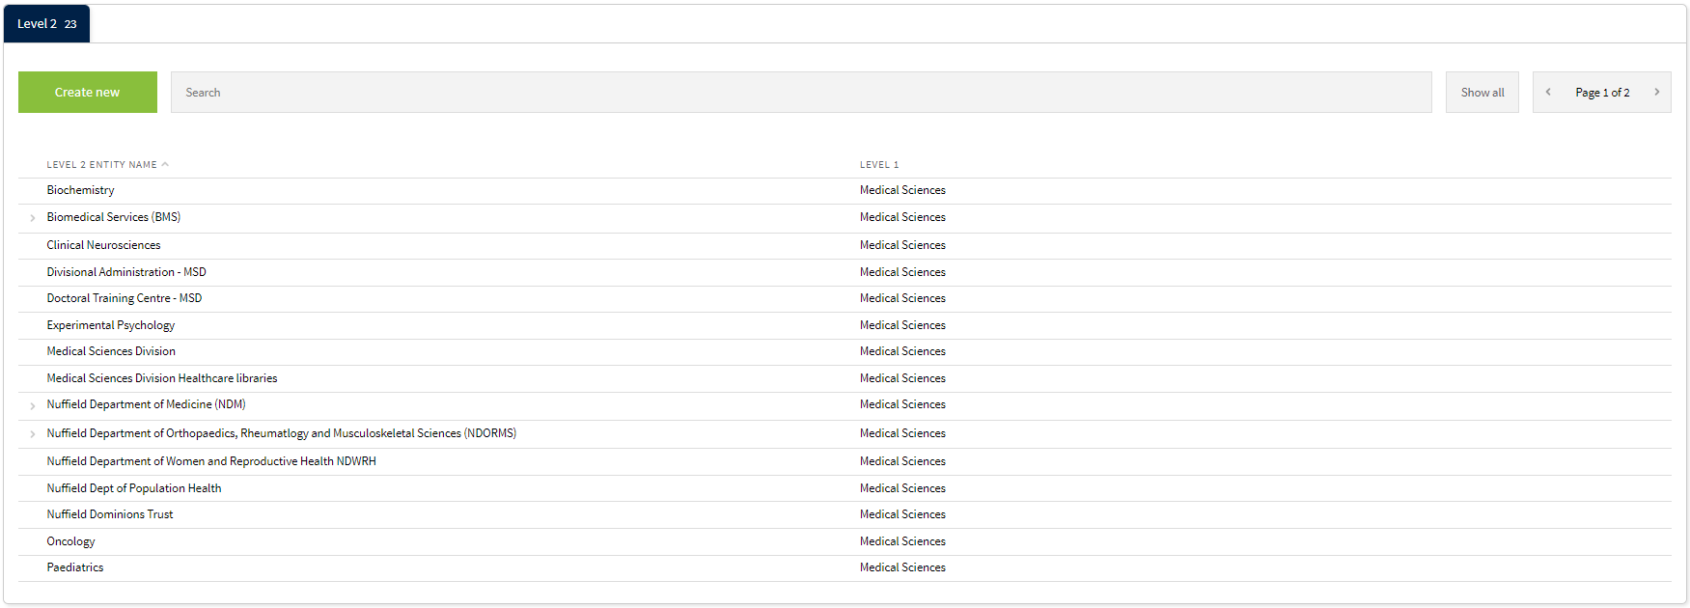
This in turn opens a list of Level 3 Entities associated with that Level 2 Entity. Select the correct Level 3 Entity (in this example Human Genetics – Henry Wellcome Building (HWB))

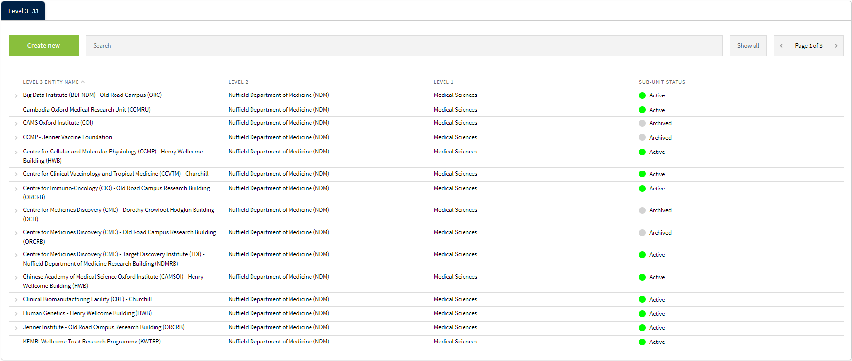

This will open up details for this Level 3 Entity. Click on the ‘Configuration’ button in the blue banner at the top of the page. Click on Permissions in the menu that appears.

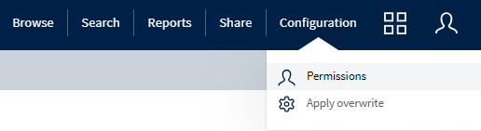

This will open up a list of users that have permissions for this entity. First listed are those with unrestricted access on the system. Generally this is the supplier, members of the IRIS Support Team, and Safety Office staff.

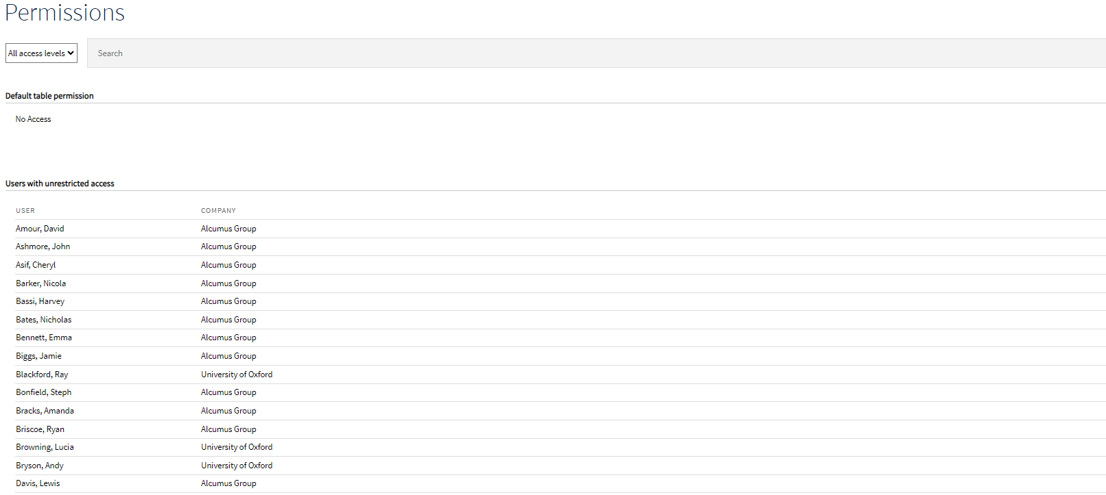

Further down the page are users who have permissions granted automatically. These users have their permissions assigned at either the Level 1 or 2 Entity and these have trickled down to this Level 3 Entity.

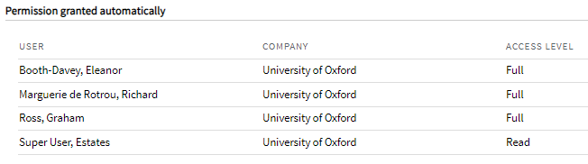

Lastly is the Override Permissions section. This is where we can assign permissions for this entity. To do this click on Add User Override.

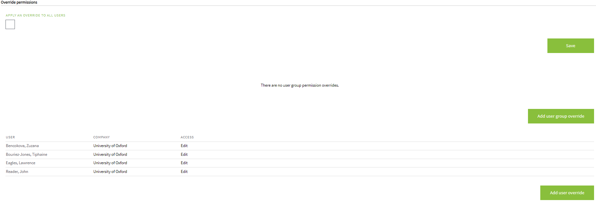

Click on the […] button to open the list of users on the system.

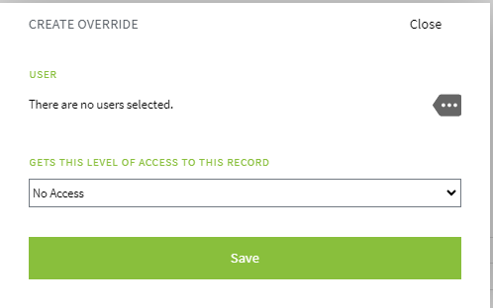

Select the user to add permissions for. You can locate them either by using the search bar or the alphabet prompts for their surname. Tick the box next to their name and then Ok.

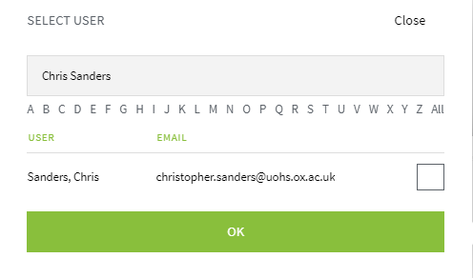

From the dropdown list select the appropriate access level and then click Save.

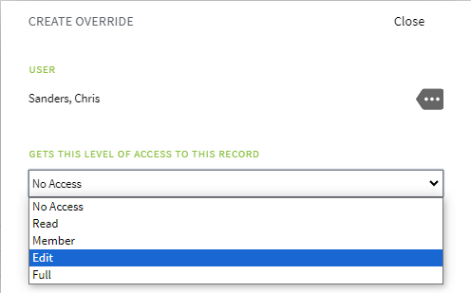
Access Levels
For most user groups the appropriate access level is ‘Edit’ that should be applied to a Level 3 entity. This will allow them to complete and update incidents on the system.
For Area/Divisional Safety Officers ‘Full’ access should be granted to a Level 1 or 2 entity. This will allow them to use the full range of functionality open to them.
For those requiring read only access, ‘Read’ access should be granted to the appropriate entity.

The user has now had their permissions added for this entity. Click Save. Repeat for any other entities that the user needs permissions for.

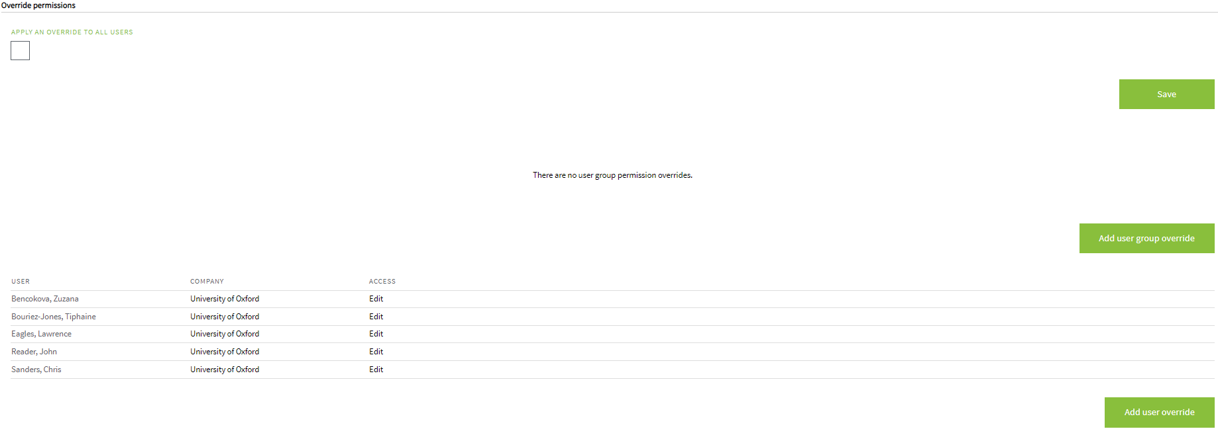

NB. If a user requires permissions for multiple level 3 entities that sit under the same parent level 2 entity, these need to be applied separately in each level 3 entity. Granting them access to the level 2 entity that sits above them will not result in the correct access being applied.

  - Amending a user account and amending permissions

    - Amending a user account

Navigate to the user in the Administration section of IRIS using the search field if required. Click on their name to open their details.

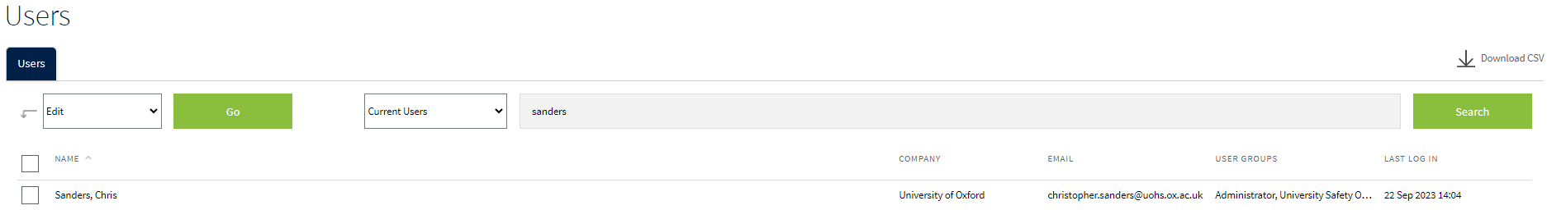

Amend the Forename, Surname, Email Address, or Authentication ID as required. Click Save at the bottom of the page when the changes have been made.

    - Amending a user’s permissions

Navigate to the Structure section of the system.

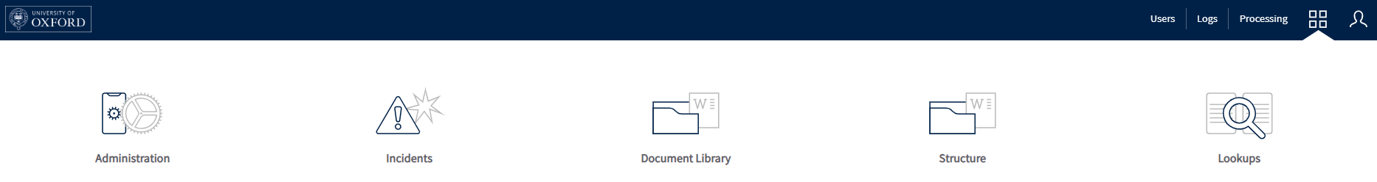

Navigate to the Entity that the user’s permissions need editing on. This may be a Level 1 (Division), Level 2 (Department), or Level 3 (Sub-department) Entity. Use the tabs and search field, or navigate from the Level 1 Entity down to find the Entity in question. Click on the Entity to open it.

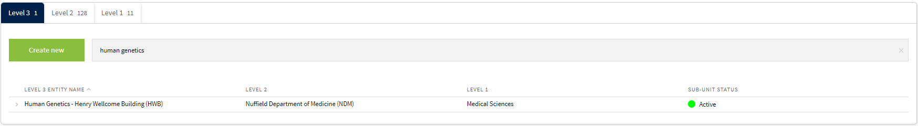

Click on the ‘Configuration’ button in the blue banner at the top of the page. Click on Permissions in the menu that appears.



Click on the user’s name to edit their permissions for this entity.

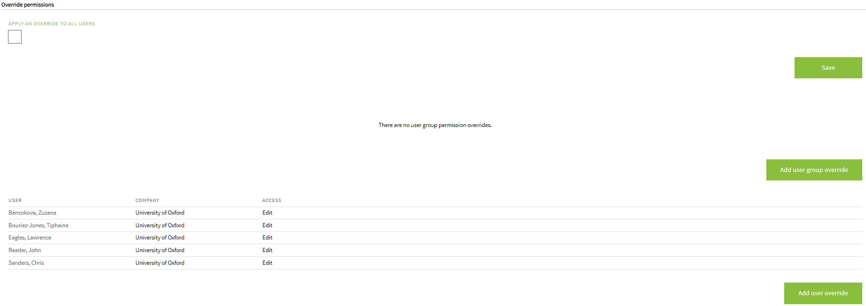

In the pop-up window, click Delete.

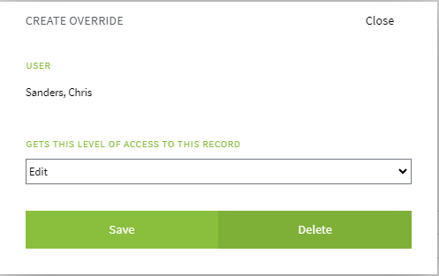

Click Save to confirm the changes.
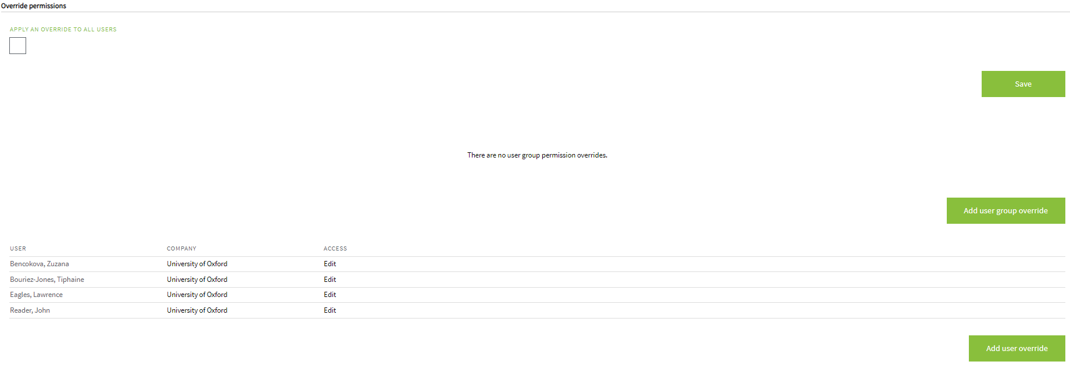
This process will need to be deleted for any other entities that the user may need their permissions changed for.

  - Removing a user from the system

Navigate to the user in the Administration section of IRIS using the search field if required. Click on their name to open their details.

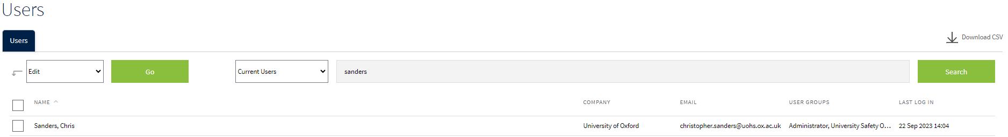

On the right-hand side of the screen, click on Archive

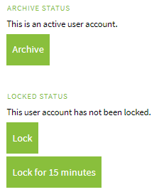

Click Save at the bottom of the page.

No user account is permanently deleted from the system – accounts are archived until a point when they are needed again. To reactivate an account, navigate to it and click De-archive.

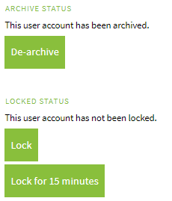

- Adding/Amending/Removing Department Details

The following steps can be followed to make changes to any Level 1, 2 or 3 Entity on the system. It is worth checking with a relevant Area/Divisional Safety Officer whether these changes are required if the request has not come from them.

  - Adding a new department

Navigate to the Structure section of the system.

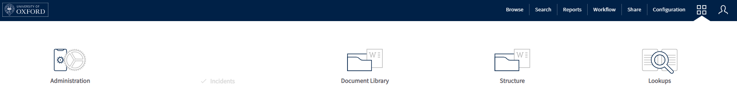

Navigate to the relevant entity tab where the new entity needs to be added e.g. If a new Level 3 Entity needs to be added to the “Nuffield Department of Medicine – NDM”, navigate to the Level 2 Entity of that name to add the new Level 3 Entity associated to it. Click on the entity’s name to open it.

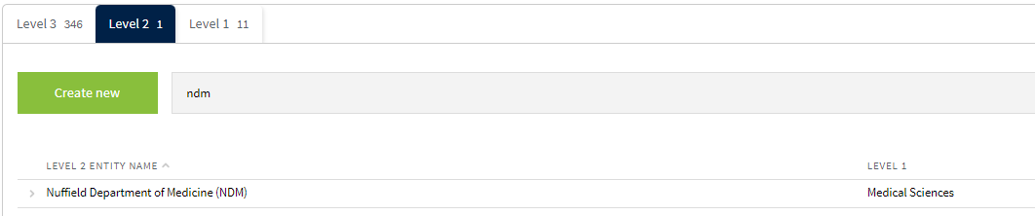

The list of entities below the selected entity will be displayed. In this example, all the Level 3 Entities associated with the Level 2 Entity Nuffield Department of Medicine – NDM are displayed. Click on Create new Sub-Unit.

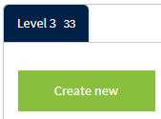

Enter the name of the new entity. Note that the parent entity has already been populated. Click Save Changes when done.

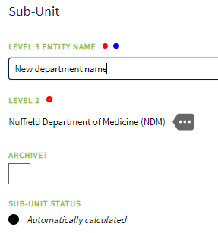

Refer to the guide on how to grant users permissions to this entity.
  - Amend a department’s details

Navigate to the Structure section of the system.



Navigate to the relevant entity tab where the new entity needs to be amended. Click on the entity to open it up.



Amend the name of the entity or select a new parent entity to change where it sits in the structure of the University. Click Save Changes when done.



  - Remove a department from IRIS

This should not be performed on the system by the IRIS Support Team and requires escalating to the Business Change Analyst

- Adding/Amending/Removing Building Details

The University is complex and new buildings are popping up or being renamed all the time. Like with changes to departments, it is worth verifying any requests with Area/Divisional Safety Officers if the request did not come from them.

  - Adding a new building

Navigate to the Lookups section on the Homepage.

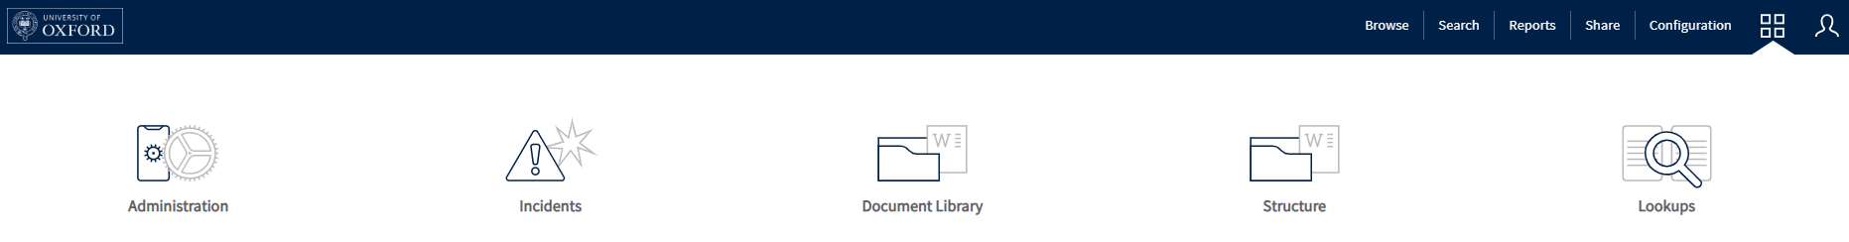

Click on Incidents to expand the selection.

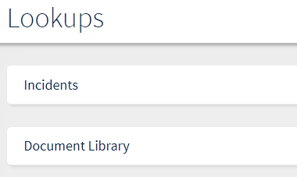
This will display a list of lookup fields in use on the system. Select Building. You may need to scroll along the list of look up fields using the left and right arrows.

The list of buildings on the system is now displayed. Verify that the building to be added is not already on the list using the search field. If the building does not exist, click on Create New Building.

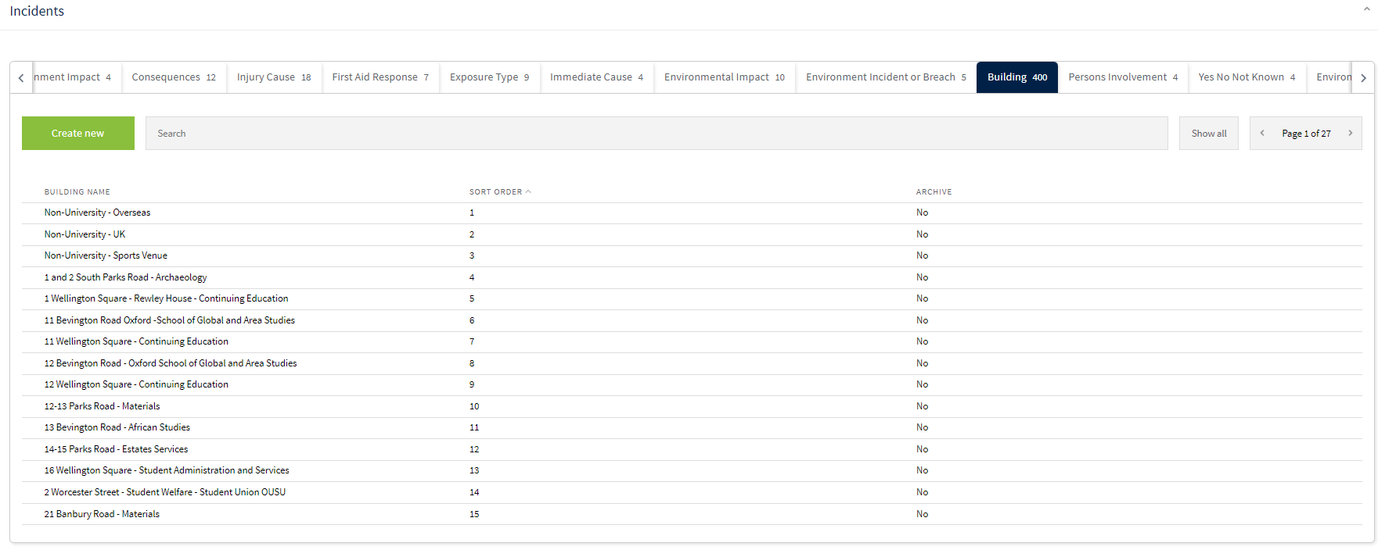

Enter the details for the Building Name and Sort Order. Enter the Estates Number (PlanOn building number) if known. Click Save Changes once done.

NB. The Sort Order must be a unique number and determines where the building appears in the dropdown list to select a building. The previous screenshot showed in this example that there are 400 building entries already on the system meaning this new one will be the 401st. Best practice would be to enter the next sequential number as the Sort Order, in this example 401.

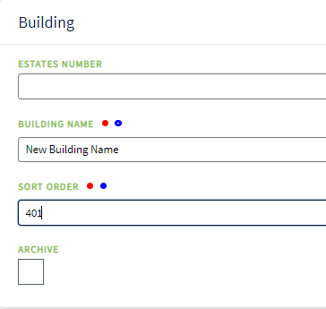

The building has now been added to the dropdown list as a selectable option.

  - Amend a building’s details

Navigate to the Lookups section on the Homepage.



Click on Incidents to expand the selection.

This will display a list of lookup fields in use on the system. Select Building.



The list of buildings on the system is now displayed. Search for the building to be amended using the search field on the page. Click on the building to open it.



Make the required changes to any of the fields on the screen. Click Save Changes when done.



  - Remove a building from IRIS

This should not be performed on the system by the IRIS Support Team and requires escalating to the Business Change Analyst.

- Reassigning Incidents from one Department to another

Reporters of incidents are asked to assign each incident they log to a Department, Faculty or School where the incident took place. This is not always a clear-cut decision due to the complex nature of the University and the buildings and spaces it occupies. There are some situations where it can be easy to assign an incident to an incorrect department to process.

A user on the system can reassign incidents between departments only if they have permissions to view incidents that take place in both of these departments i.e. if an incident was assigned to the Maths Department but should have been assigned to the Physics Department, a user could only reassign this if they had permissions to view incidents in both the Maths and Physics Departments. This means that the likelihood is only Area or Divisional Safety Officers are likely to be able to reassign incidents within their divisions, and Departmental Safety Officers are likely to not be able to do this.

As a result, we will receive requests to reassign incidents between departments that have been given incidents to process in error.

NB. When asked to reassign an incident, ensure that you are given the department that it should be assigned to. It is not your responsibility to decide who should process it. That rests with the department requesting the change.

Navigate to the Incidents section from the Homepage.

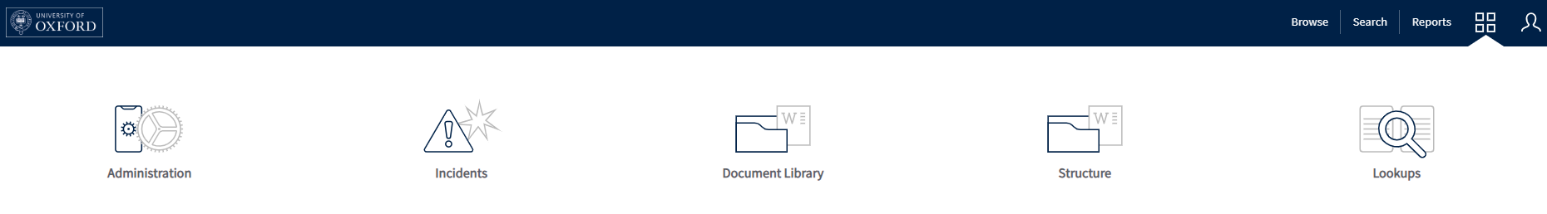

Locate the incident from the list of Incidents. The tabs and search field may be of use. Click on the Incident Reference Number to open the incident in question.

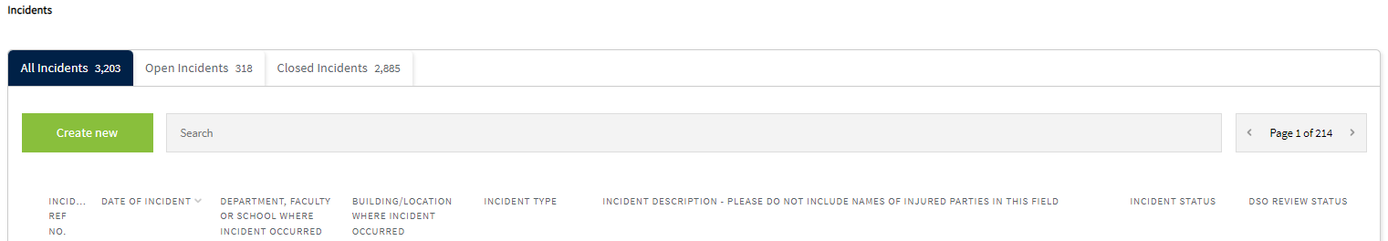

Details of the incident are then displayed. Click on Edit Incident at the bottom of the page to open it up to make changes.

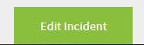

All the fields in the Incident Form are then displayed and are editable. Open the list of departments by clicking the […] button by Department, Faculty or School where the incident took place field.

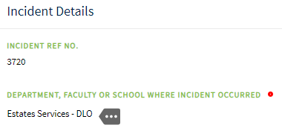

In the pop-up window locate the department that was originally selected by using the search field or browsing through the pages of departments. Unselect the department by ticking on the box. Repeat this process to locate the new department to be assigned the incident and tick the box to select it.

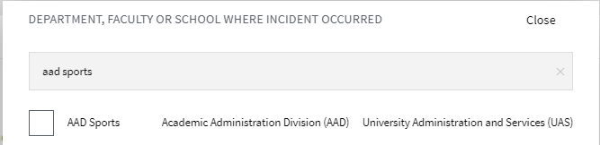

At the bottom of the screen click on Save Changes.

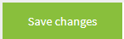

This has now reassigned the incident to the new department.

- Amending details on Incident Forms

Once an Incident Form has been submitted to IRIS, the reporter cannot edit the form. This means that if they have made any errors in any fields or forgot some information to include they cannot make those changes.

We may receive requests therefore to amend Incident Forms from those who have reported the incident.

NB. All users on the system, including DSO’s, can add this missing information for incidents that they have permissions to view.

Navigate to the Incidents section from the Homepage.



Locate the incident from the list of Incidents. The tabs and search field may be of use. Click on the Incident Reference Number to open the incident in question.



Details of the incident are then displayed. Click on Edit Incident to open it up to make changes.



All the fields in the Incident Form are then displayed and are editable. Make any changes as required. Click Save Changes at the bottom of the page once done.

- Functionality Changes

Other requests may take the form of changes to functionality on the system. These could be small changes such as changes to a dropdown field or larger changes such as how workflows work.

In all instances of these types of query, escalate this to the Business System Manager who will advise whether the change can be made or needs escalating. This is because some dropdown fields have workflows or conditional formatting that is driven by the responses selected.

The Business Service Manager will escalate these issues to either the IRIS Product Ownership Group (POG) for discussion before advising of what processing will take place, or to the supplier for processing.

  - Amend options in a dropdown list

Once you have received confirmation from the Business Service Manager to make the change, use the following steps.

Navigate to the Lookups section on the Homepage.



Click on Incidents to expand the selection.


This will display a list of lookup fields in use on the system. Select the relevant look up to amend. In this example Buildings have been selected. You may need to use the left and right arrows to find the look up field in question.



The list of options in that look up will then be displayed. Either click on the option to be amended, or click on Create New […] to add a new option.

Make the required changes to any of the fields on the screen. Click Save Changes when done.

